**Understanding Closures**

* Even if the Function Execution context ends, all the variables/memory associated would remain

**STEP 1**

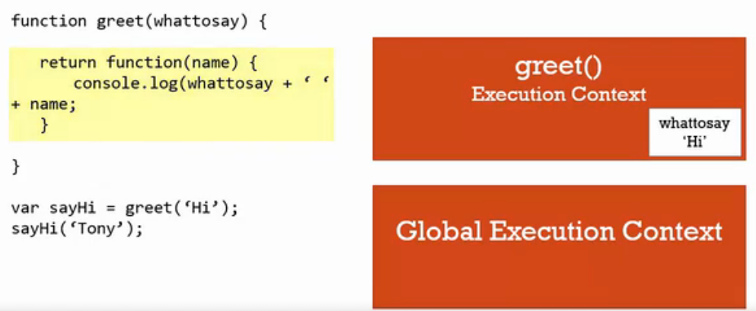

**STEP 2**

* After function execution is completed, function execution context goes away. Under normal cases

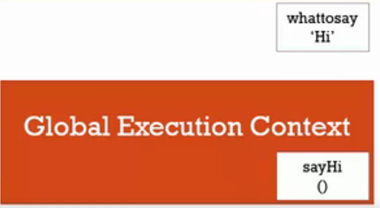

**STEP 3**

When sayHi(‘Tony’) is invoked, new function execution context is created.

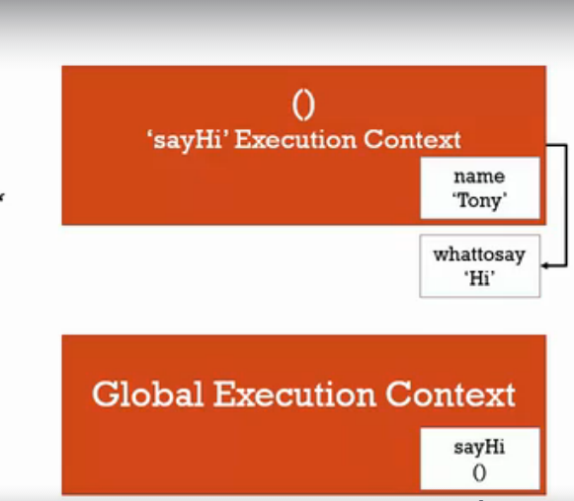

**Closures : Part 2**

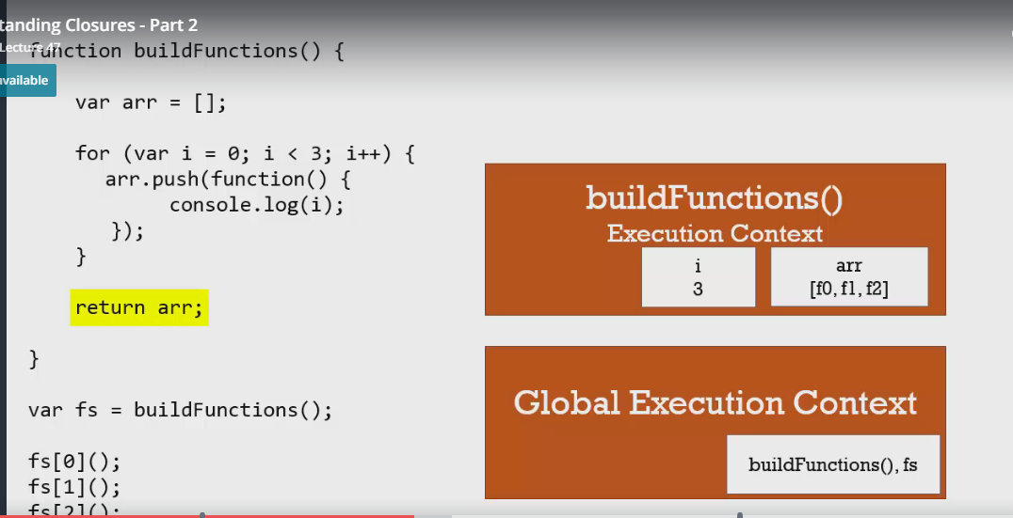

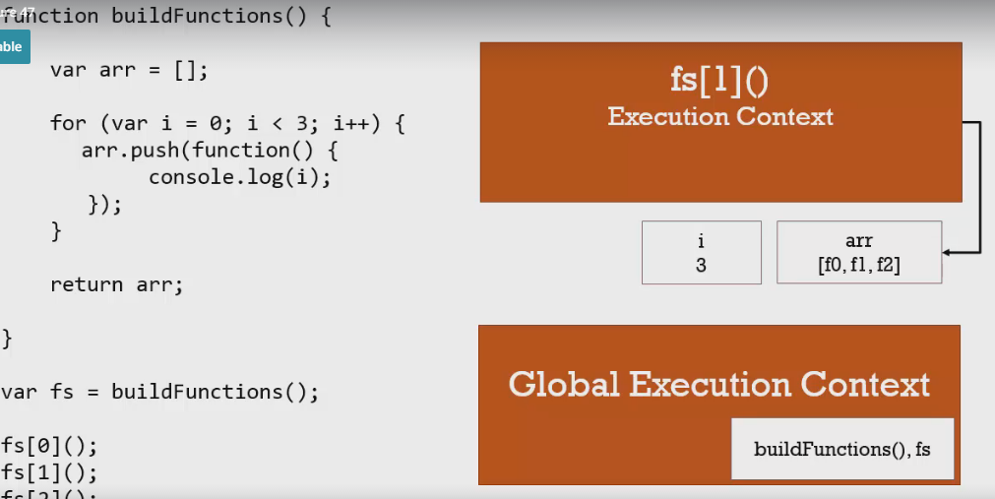

**Output** 3 3 3

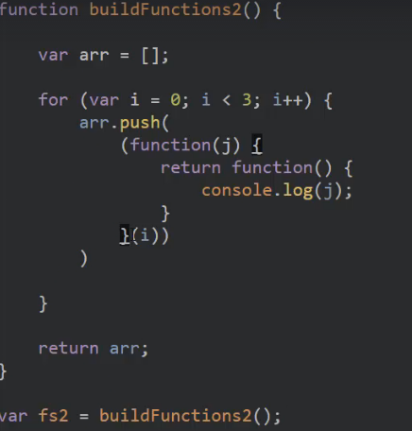

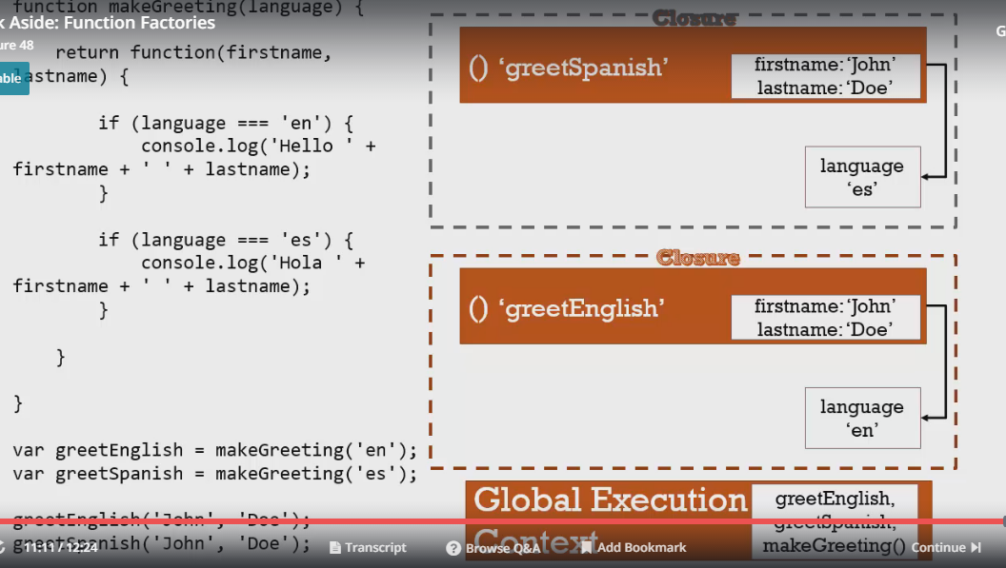

**CallBacks**

